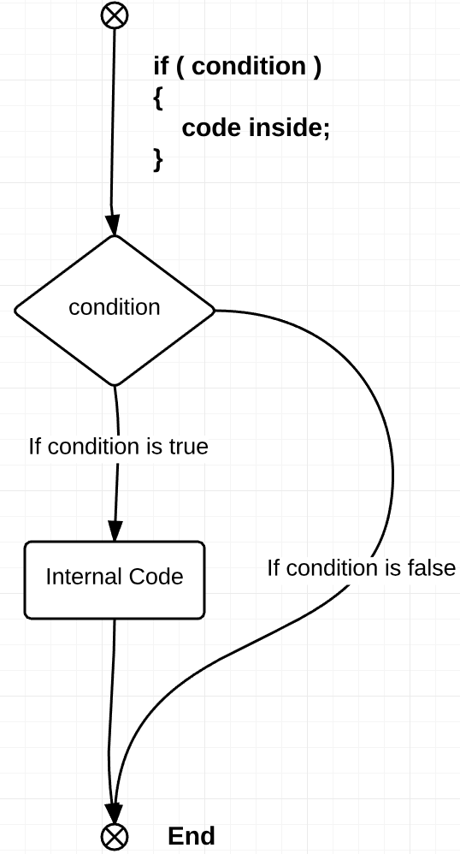This level introduces obstacles that can destroy the mars explorer if the user keeps going forward without “if” statement. Therefore, the code used in Levels 3 and 6 would not work. It is another very commonly used function that is even simpler that “while” loops are.

It is slightly different from “while” loop in a way such that it does not repeat the loop until the condition is false. The code that is within the statement will only be executed once. In case when condition is not met at the very start, the whole peace of the code that is within the statement will be avoided by the program. *See Figure 1 for further reference.*

As with “while” loops, programmers use “if” statements almost in every application they create. Even complex analytical software includes “if” cases. For example, in order to analyse the market of shares, people buy expensive applications that predict future behaviour of those shares raising chances for a successful investment. The bases of these programs is to have a few “if” cases, that will consider the necessary factors and then display either increasing slope, or decreasing.

The applications might not even have complex logic in it, but considering all the factors and writing them once will save a lot of time as you do not need to re-considering the same issues every time you perform the same action. That is why programming is so important to know for almost any person: will it be a doctor or a businessman.

Figure 1: "if" statement